ARYAMAN MISHRA

19BCE1027

<!DOCTYPE html>

<html lang="en">

<head>

<meta charset="UTF-8">

<title>Registration Page</title>

<link rel="stylesheet" type="text/css" href="1.css">

<link rel="stylesheet" type="text/css" href="https://stackpath.bootstrapcdn.com/bootstrap/4.4.1/css/bootstrap.min.css">

<script type="text/javascript">

function required()

{

var count=0;

var ticket;

document.getElementById('tickets').innerHTML = ticket;

var t = parseInt(ticket, 10);

if(t>=2 && t<=5)

{

count=count+1;

}

else

{

alert("Book tickets between 2 and 5");

}

}

</script>

</head>

<body>

<div class="container">

<div class="register-box">

<div class="row">

<div class="col-md-12 login-right">

<h2> Welcome to Marina Mall Online Cinema</h2>

<form action="Untitled-3.php" method="post">

<div class="form-group">

<label>Movie Name</label>

<input type="text" name="movie" class="form-control" required>

</div>

<div class="form-group">

<label>Show-time</label><br>

<input type="radio" id="AN" name="A" value="AN">

<label for="AN">AN</label><br>

<input type="radio" id="FN" name="F" value="FN">

<label for="FN">FN</label><br>

</div>

<div class="form-group">

<label>Date for Movie</label>

<input type="date" name="dob" class="form-control" required>

</div>

<div class="form-group">

<label>Number of Tickets</label>

<input type="text" name="tickets" class="form-control" required>

</div>

<div class="form-group">

<label>Email</label>

<input type="text" name="email" class="form-control" required>

</div>

<button type="submit" class="btn btn-primary"> Register </button>

</form>

</div>

</div>

</div>

</div>

</body>

</html>

Untitled-3.php

<?php

session_start();

$con = mysqli_connect('localhost', 'root', '');

mysqli_select_db($con, 'marina');

$movie = $_POST['movie'];

$A = $_POST['A'];

$F = $_POST['F'];

$tickets = $_POST['tickets'];

$email = $_POST['email'];

$s = " select * from users where movie = '$movie'";

$result = mysqli_query($con, $s);

$num = mysqli_num_rows($result);

if($num == 1){

echo "Invalid Input";

}else{

$reg = " insert into users (movie, A, F, tickets, email) values ('$movie', '$A', '$F', '$tickets' ,'$email')";

mysqli_query($con, $reg);

$_SESSION['movie'] = $movie;

header('location:Untitled-4.php');

}

?>

Untitled-4.PHP

<?php

session_start();

if(!isset($_SESSION['movie'])){

header('location:Untitled-1.php');

}

?>

<!DOCTYPE html>

<html lang="en">

<head>

<meta charset="UTF-8">

<title> Intermediate Register Status Page </title>

<link rel="stylesheet" type="text/css" href="1.css">

<link rel="stylesheet" type="text/css" href="https://stackpath.bootstrapcdn.com/bootstrap/4.4.1/css/bootstrap.min.css">

</head>

<body>

<div class="container">

<a class="float-right" href="Untitled-1.php"> HOME </a>

<h1> Registration done successfully!!! <?php echo $_SESSION['movie']; ?> </h1>

</div>

</body>

</html>

1.css

@charset "utf-8";

/* CSS Document */

body{

background: linear-gradient(rgba(0, 0, 0, 0.5), rgba(0, 0, 0, 0.5)), url("image3.jpg");

height: 100vh;

background-size: cover;

background-position: center;

position: relative;

}

.register-box{

max-width: 700px;

float: none;

margin: 150px auto;

}

.login-box{

max-width: 700px;

float: none;

margin: 150px auto;

}

.login-left{

background: rgba(211, 211, 211, 0.6);

padding: 30px;

}

.login-right{

background: rgba(211, 211, 211, 0.4);

padding: 30px;

}

.form-control{

background-color: transparent !important;

}

a{

color: #fff !important;

margin-top: -200px !important;

}

h1{

color: #fff !important;

margin-top: 200px !important;

text-align: center;

text-transform: uppercase;

}

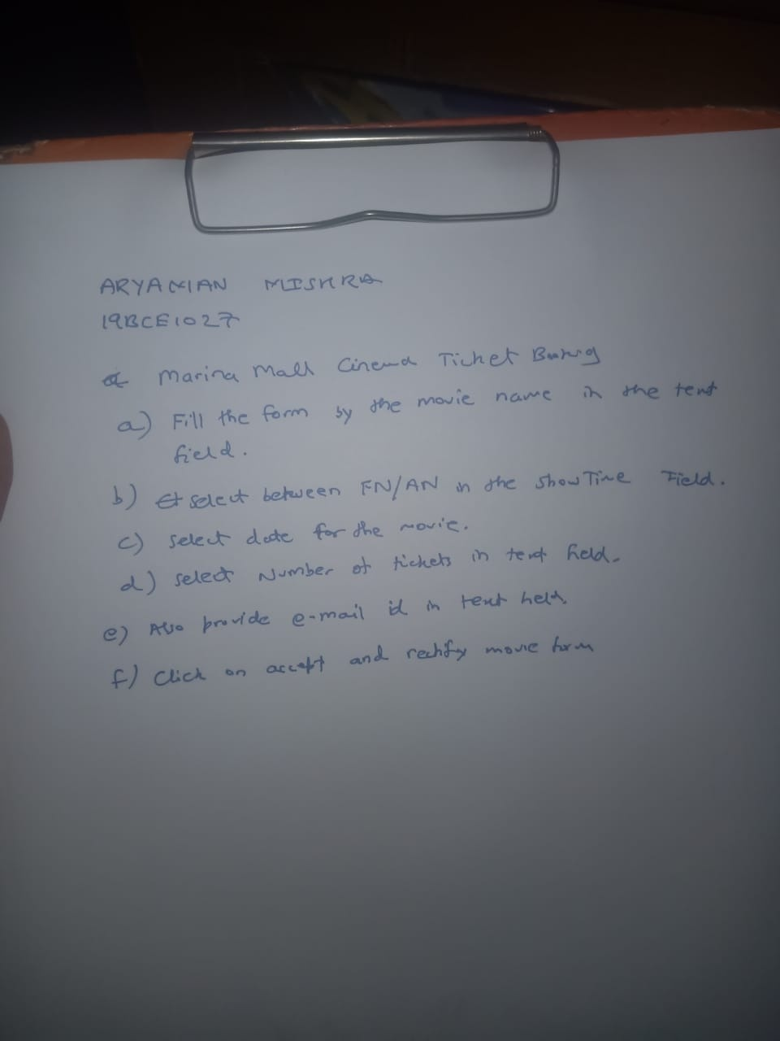

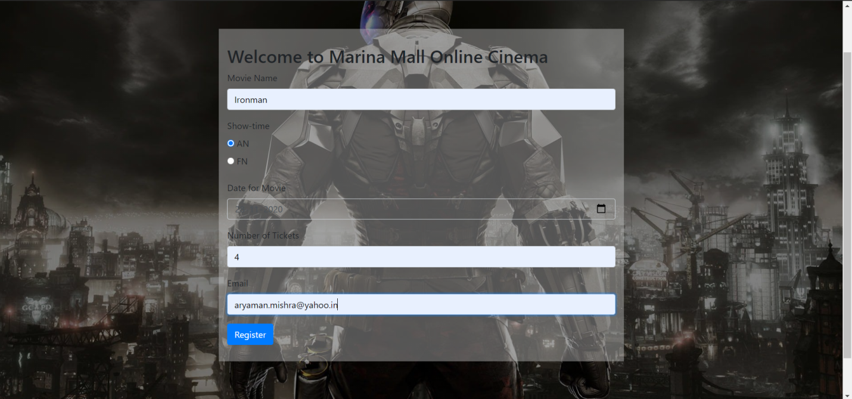

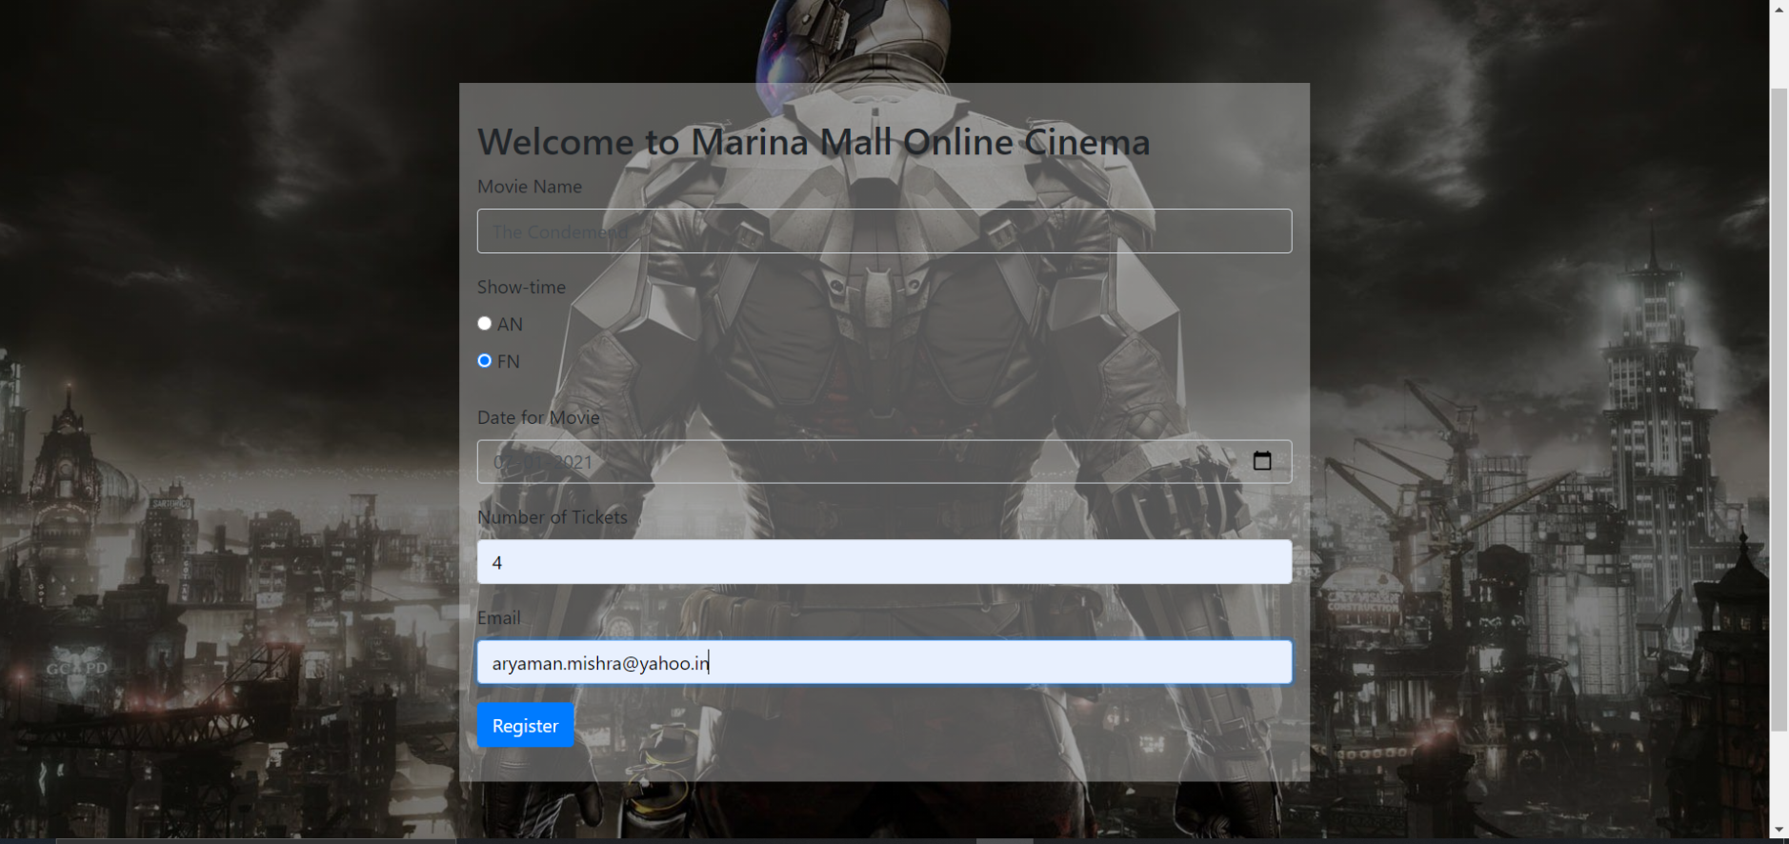

Fail Case:

